W-PAST User’s Manual

Liam Berigan, Amber Roth, Erik Blomberg, Lisa Williams, Ken Duren, Scott Bearer, Timothy Haydt, Daniel Jones

January 29, 2022

Questions? Contact: [liam.berigan@maine.edu](mailto:liam.berigan@maine.edu)

Table of Contents

Overview 2

What is W-PAST? 2

Migratory & breeding season layers 2

Migratory layer 2

Data used for the migratory layer 2

Breeding season layer 2

Data used for the breeding season layer 3

Modeling methods 3

Limitations of W-PAST 3

How to use W-PAST 4

Instructions Page 4

Application Page 5

Tab: Layer & Weight 5

Toggle: Layer view 6

Option: Statewide layer 6

Option: Gamelands: landscape suitability index 7

Option: Gamelands: average pixel value 7

Toggle: Migratory and breeding habitat weight 7

Tab: Gamelands within view 7

Statistic: Landscape suitability index 8

Statistic: Average pixel value 8

Statistic: Gameland acreage 8

Interacting with state gamelands in the map viewer 8

Statistic: Percentile 9

Statistic: High suitability 9

Statistic: Moderate suitability 9

Changing display options in the map viewer 9

# Overview

## What is W-PAST?

W-PAST uses landscape-scale variables (including fragmentation, land use/land cover, topography, and soil moisture) to predict where woodcock habitat management is likely to be successful. Based on breeding season surveys and GPS locations from woodcock migratory stopovers, the tool makes separate predictions for woodcock during the breeding and migratory seasons. Users can weight these seasonal layers based on the relative importance of breeding and migratory habitat to their management strategy.

### Migratory & breeding season layers

#### Migratory layer

Migratory habitat is here defined as habitat used at stopover sites, which are areas that woodcock use to rest, refuel, and avoid predation between nocturnal migratory flights. Stopover length is highly variable for woodcock; they may spend a single day at a stopover site, or they could remain there for several weeks. In Pennsylvania, woodcock are more widely distributed during the migratory season, and may stop over in regions (such as southeast Pennsylvania) that they rarely occupy during the breeding season. They are also more tolerant of heavily fragmented landscapes and landscapes with low forest cover, including highly developed landscapes. Urban centers such as Philadelphia are ranked highly by the migratory model, and greenspaces in urban areas are presumed to be valuable stopover habitat.

##### Data used for the migratory layer

The migratory layer was created using GPS data from the Eastern Woodcock Migration Research Cooperative (EWMRC) to designate woodcock migratory stopover sites throughout the state of Pennsylvania. The EWMRC is a collaboration of 34 federal, state, provincial, non-profit, and university partners throughout the United States and Canada that has been deploying transmitters on woodcock since 2017 throughout the eastern portion of their range (www.woodcockmigration.org). The Pennsylvania Game Commission (hereafter PGC) has been deploying transmitters as a part of this cooperative since 2018, and the GPS locations used to build this layer include locations from PGC-tagged birds as well as birds tagged by other cooperators throughout eastern North America. The tags applied to woodcock are 4g, 5g, and 6.3g PinPoint GPS Argos tags (Lotek Wireless Inc., Newmarket, Ontario, CA), which record locations at 12 — 60m accuracy depending on cover type. Tags were programmed to record locations every 1 — 3 days at 0900 or 1500 Eastern Time, outside of the woodcock’s nocturnal flight period.

#### Breeding season layer

Breeding season habitat is here defined as areas used between the spring and fall migratory movements, during which woodcock mate, nest, and raise broods. Breeding areas in Pennsylvania are traditionally monitored using Singing Ground Surveys between April 15th and May 5th, but woodcock tend to remain in the same areas and use similar landscape-scale habitat from May 15th through September 15th. Breeding season habitat in Pennsylvania is regionally concentrated in areas with ~75% forest cover and ~25% agricultural cover within 10km and is rarely present in areas with >30% developed cover within 10km.

##### Data used for the breeding season layer

The breeding season layer was created using federal Woodcock Singing Ground Surveys and similar state-level surveys conducted by the PGC. Singing Ground Surveys, which were originally established in 1968, consist of 5.76 km survey routes with 10 evenly spaced points. Presence-absence is determined at each point based on whether male displays were visible during a 2 minute interval shortly after dusk. Singing Ground Survey routes are randomly distributed throughout Pennsylvania, and the same routes are run annually when possible. PGC woodcock surveys are run using the same methodology, but these routes are placed near state gamelands or in areas where managers believe woodcock occupancy is likely. We converted state and federal survey data from 2016 — 2020 to a presence-absence dataset by marking each survey point as present if there were woodcock observed at that point at least once during the 5-year interval, and absent if they were not. Presence-absence locations were then used as the response variable in the breeding season species distribution model.

#### Modeling methods

Both the migratory and breeding season models were created using a Random Forest classifier, which is a machine learning algorithm that excels at modeling non-linear relationships. The explanatory variables in the species distribution model included several suites of variables presumed to be relevant to woodcock habitat. These included variables representing land use/land cover, forest successional class, elevation, slope, EPA level 3 ecoregions, soil drainage, and topographic wetness index. We additionally added landscape metrics representing landscape composition (% forest, % agricultural, % developed) and configuration (aggregation index, cohesion, edge density). We then used backwards variable selection to remove all variables that were not informative for the model.

### Limitations of W-PAST

W-PAST is a tool for determining where woodcock management is most likely to be successful due to the characteristics of the surrounding geography and landscape. It is not intended to show which areas are under appropriate site-level management for woodcock, or where to find woodcock. W-PAST is used most productively during the development of a habitat management plan to determine whether woodcock management in an area would result in a high probability of occupancy. It is also not recommended to use this tool to make comparisons between areas at a scale less than 1 km (the width of 4 pixels in W-PAST). Because W-PAST uses primarily landscape-scale variables to make predictions, inferences made at a < 1 km scale may be inaccurate. Instead, use clusters of at least 16 pixels (Fig. 1) to compare potential sites while determining which is most appropriate for woodcock management.

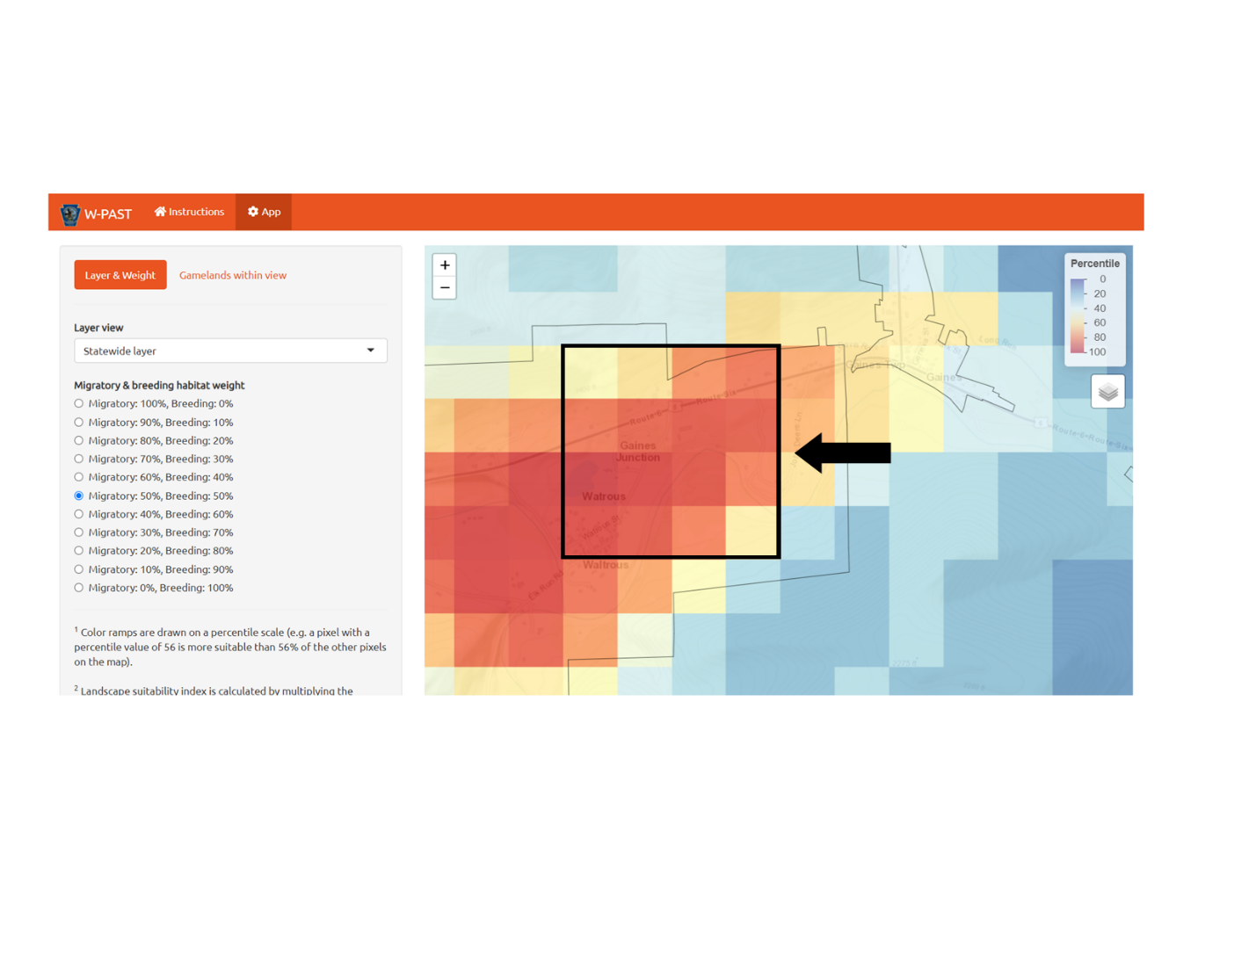

Figure 1. It is recommended to only use clusters of at least 16 pixels (a bit more than 1 square kilometer) when determining whether to manage an area for woodcock.

# How to use W-PAST

## Instructions Page

W-PAST opens on an instructions page which provides some brief details about the app, its intended use, its limitations, and links to the manual and technical report (Fig. 2). The application page can be accessed using the button labeled “Access the app here” at the bottom of the screen. The user can return to the instructions page at any time via the orange bar at the top of the screen. The rest of this document refers to the settings and features available on the application page.

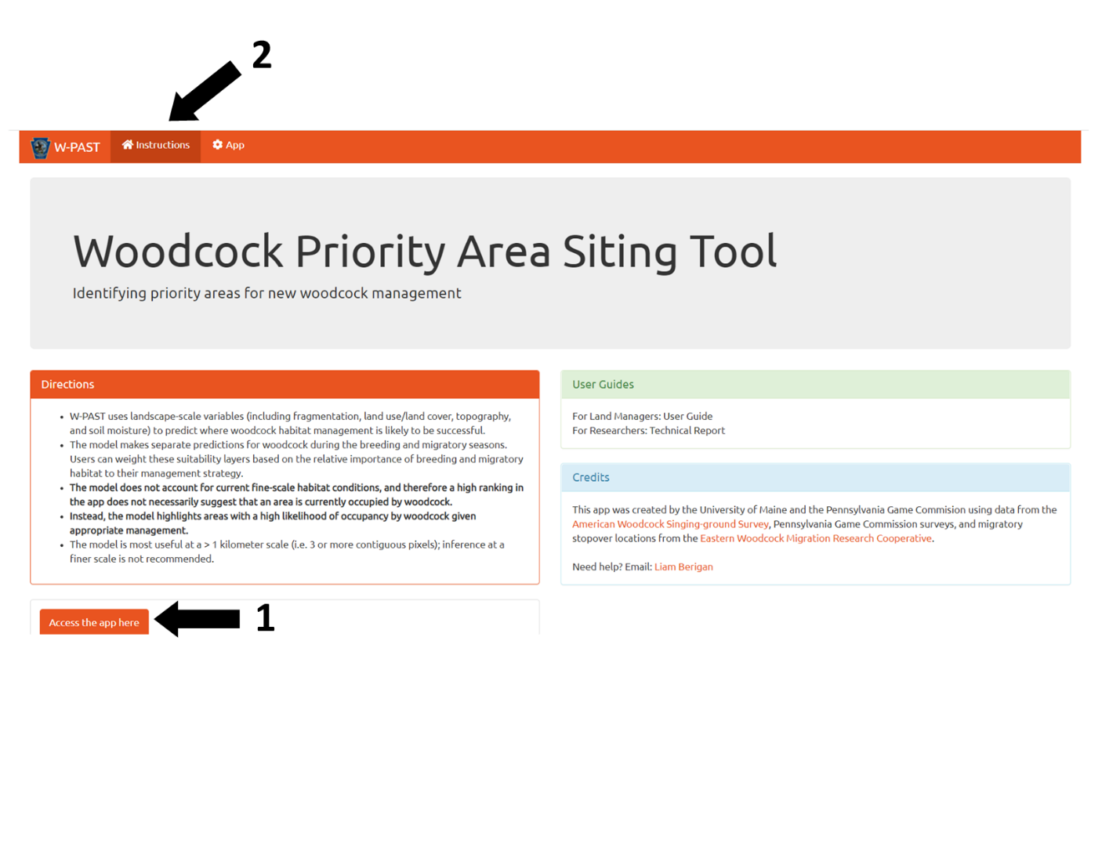

Figure 2. Instructions page. The orange button at the bottom of the screen (1) can be used to access the app, and users can return to the instructions page by using the navigation bar at the top of the screen (2).

## Application Page

The application page is composed of two main components, a sidebar on the left and a map viewer on the right (Fig. 3). The sidebar contains options for changing settings within the map viewer, and the map viewer displays how the layers change according to the current settings.

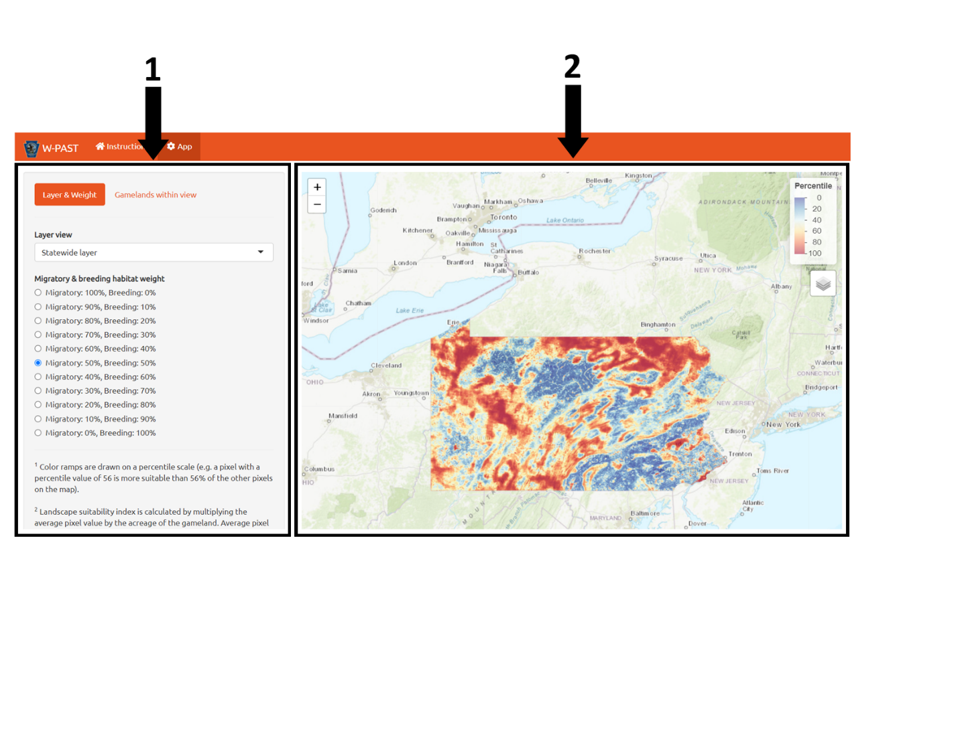

Figure 3. Sidebar (1) and map viewer (2).

## Tab: Layer & Weight

There are two tabs labeled in orange at the top of the sidebar (Fig. 4). These tabs change the options available in the sidebar. The default tab is “Layer & Weight”, which provides options for choosing the visible layer and the weighting for migratory and breeding season habitat (Fig. 5). Note that any options chosen on this tab will be preserved, even if the user navigates to a different tab.

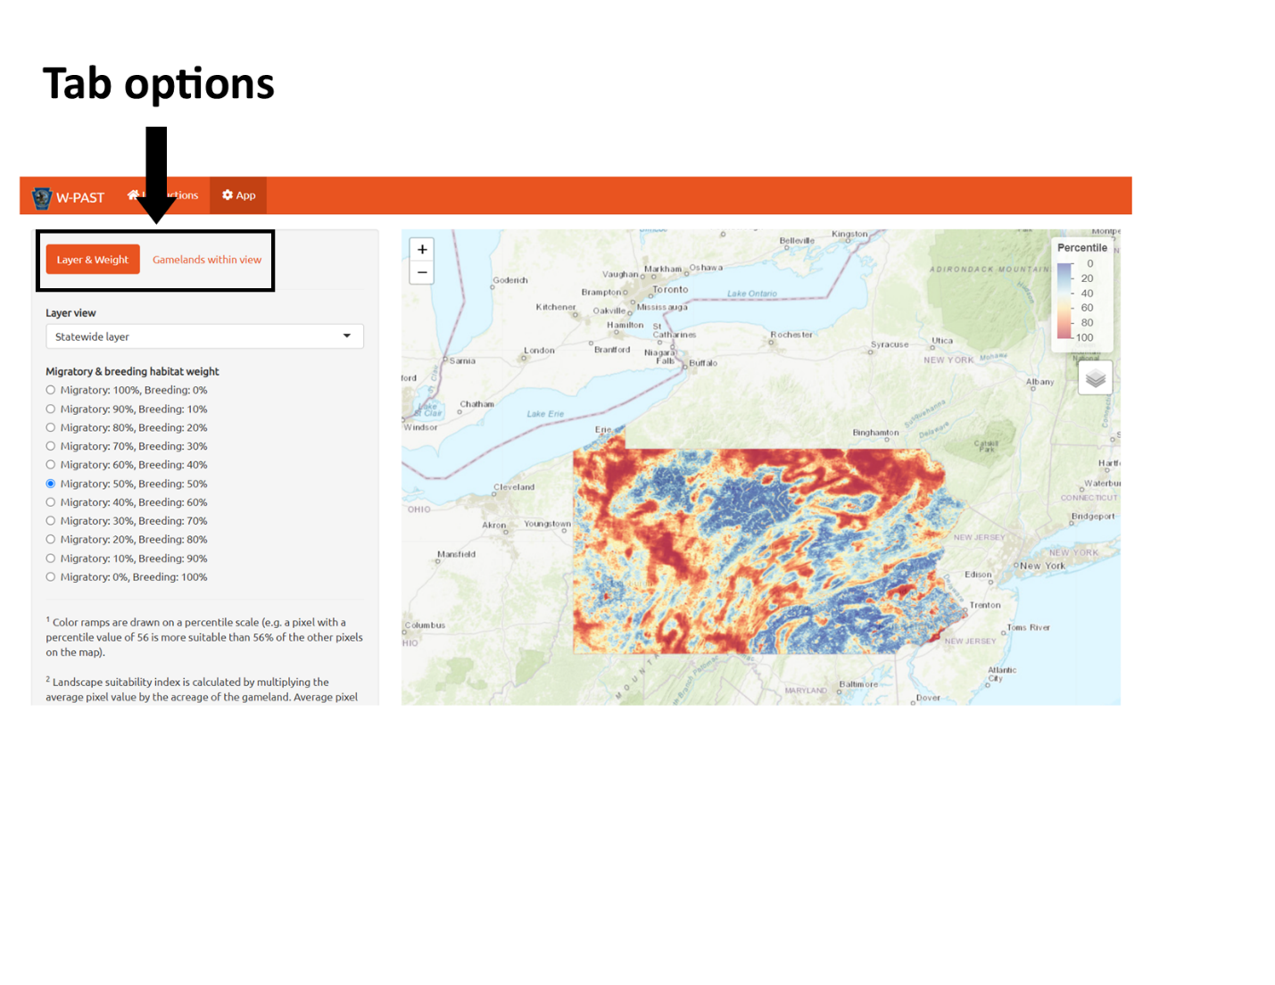

Figure 4. Tab options available in the sidebar, including Layer & Weight and Gamelands within view.

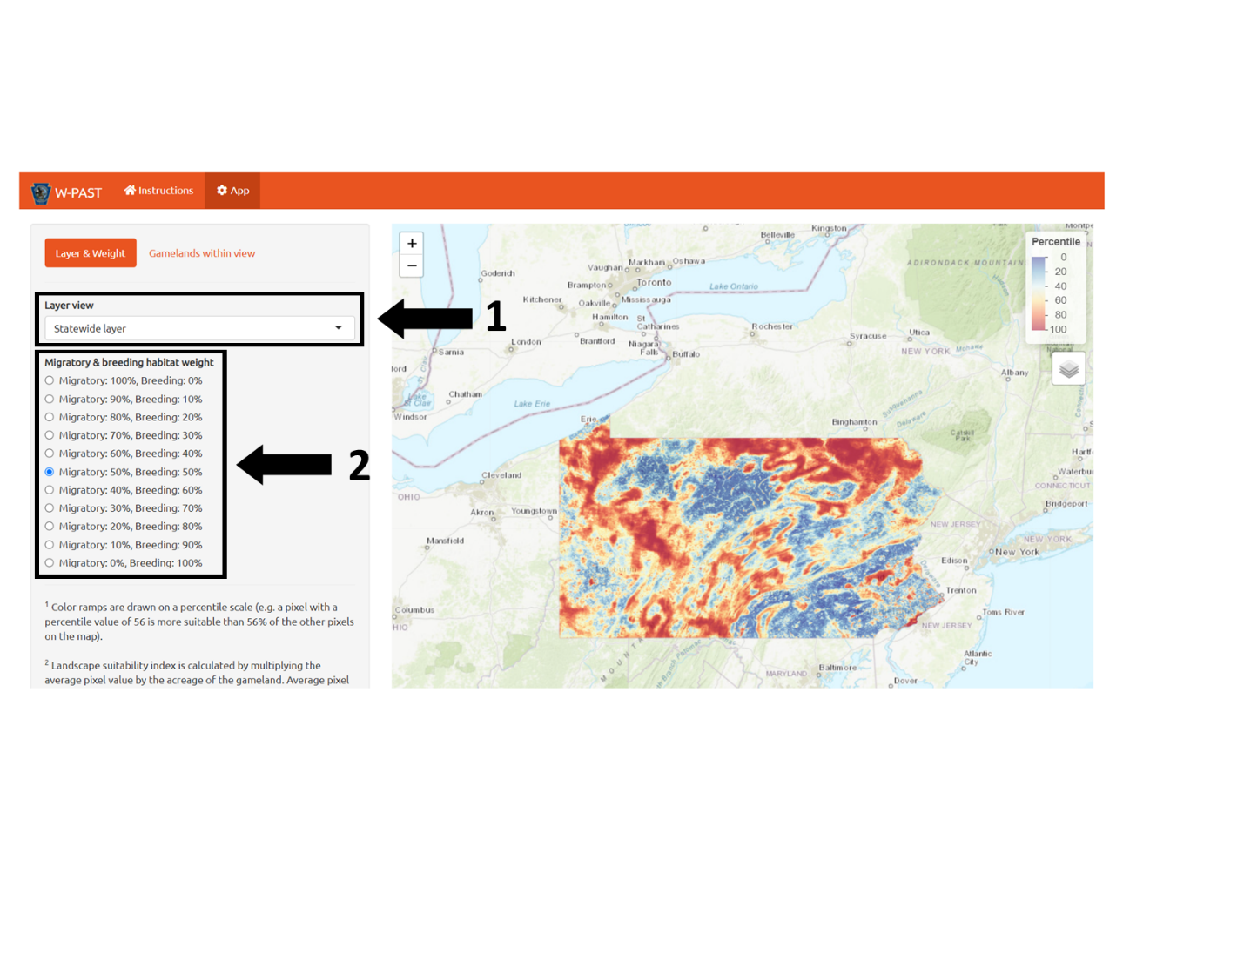

Figure 5. Toggle options available in the Layer & Weight tab, including Layer view (1) and Migratory & breeding habitat weight (2).

### Toggle: Layer view

#### Option: Statewide layer

The default layer view option is the statewide layer, which uses a predictive surface (270m resolution) to show how the potential to host woodcock habitat varies across the state. This predictive layer is scaled from 0 to 100, with 100 being the most appropriate area for woodcock management and 0 being the least. All layer view options will respond to changes in migratory and breeding habitat weight.

#### Option: Gamelands: landscape suitability index

This layer allows the user to compare the landscape suitability index of state gamelands to determine which gamelands have the greatest total potential to host woodcock. Landscape suitability index is calculated by multiplying the average pixel value of the predictive surface within the gameland by the gameland’s acreage. This metric exhibits bias towards larger gamelands and should be used in context with suitability values (see *Statistic: High suitability* and *Statistic: Moderate suitability*).

#### Option: Gamelands: average pixel value

This layer allows the user to compare the average pixel value of state gamelands. Average pixel value is calculated by averaging the values of all pixels on the predictive surface that fall within a state gameland. This metric exhibits bias towards smaller gamelands which have a high proportion of potential woodcock habitat and should be used in context with suitability values (see *Statistic: High suitability* and *Statistic: Moderate suitability*).

### Toggle: Migratory and breeding habitat weight

W-PAST supports user-determined weighting of woodcock migratory and breeding season habitat to match user priorities for management. This toggle allows the user to determine, in 10% increments, how much to weight migratory and breeding season habitat. All displays and statistics used in W-PAST are weighting-dependent, and so a change in weighting will cause these statistics to be retabulated. Migratory-only and breeding season-only layers can be accessed by setting that season’s weight to 100%.

## Tab: Gamelands within view

The Gamelands within view tab includes a table with statistics on all state gamelands currently visible in the map viewer (Fig. 6). The table updates when the view within the map viewer changes (ex. when the user zooms in) to include only those gamelands currently visible in the map viewer. Specific gamelands can also be found via the search box at the top of the table. To find a specific gameland in the map viewer, click on that gameland’s entry in the table and it will be highlighted in purple within the map viewer. All statistics in W-PAST are weighting-dependent.

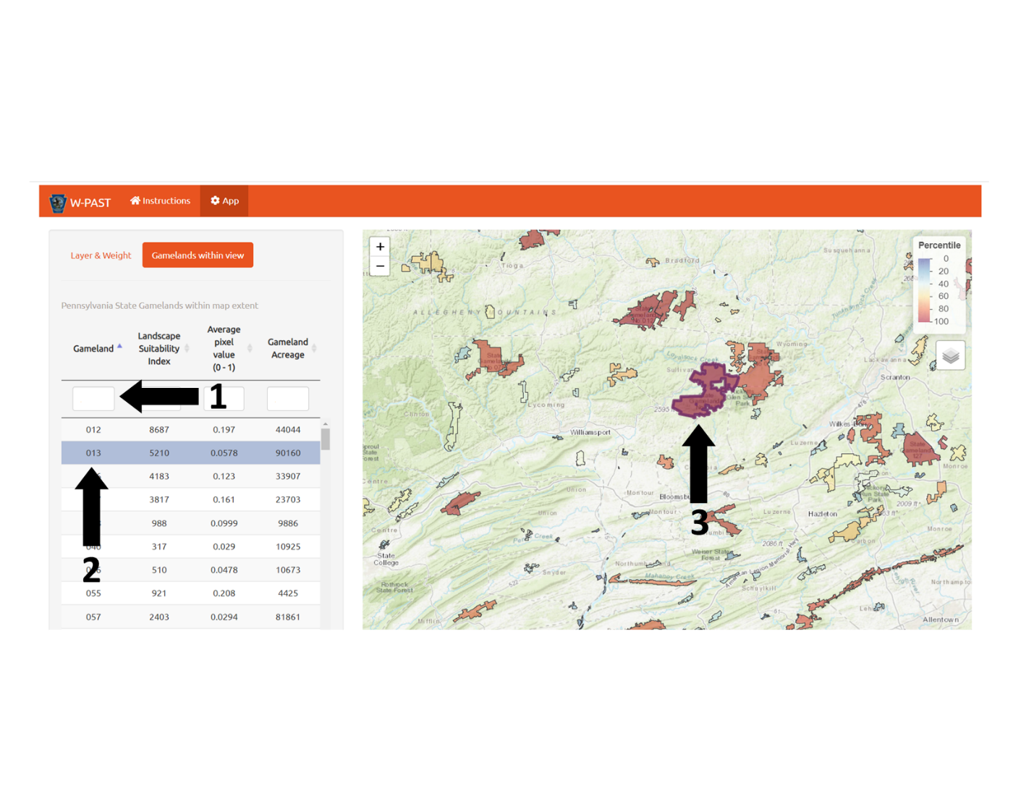

Figure 6. Gamelands within view tab. Users can type a gameland name into the search box (1) to filter the table. If users click on an entry on the table (2) the appropriate gameland will be highlighted in purple (3).

### Statistic: Landscape suitability index

Landscape suitability index shows which gamelands have the greatest total potential to host woodcock. Landscape suitability index is calculated by multiplying the average pixel value of the predictive surface within the gameland by the gameland’s acreage. This metric exhibits bias towards larger gamelands and should be used in context with suitability values (see *Statistic: High suitability* and *Statistic: Moderate suitability*).

### Statistic: Average pixel value

Average pixel value is calculated by averaging the values of all pixels on the predictive surface that fall within a state gameland. This metric exhibits bias towards smaller gamelands which have a high proportion of potential woodcock habitat and should be used in context with suitability values (see *Statistic: High suitability* and *Statistic: Moderate suitability*).

### Statistic: Gameland acreage

Gameland acreage shows the number of acres encompassed by each state gameland.

## Interacting with state gamelands in the map viewer

In any layer view option, the user can click on a state gameland to see details about the statistics for that gameland (Fig. 7). Like all statistics in W-PAST, the statistics shown in this pop-up are weighting dependent. The statistics visible in the pop-up are dependent on the layer view that is currently active (listed below).

*Statewide layer*- landscape suitability index, average pixel value, high suitability, moderate suitability

*Gamelands: landscape suitability index*- landscape suitability index, percentile, high suitability, moderate suitability

*Gamelands: average pixel value*- landscape suitability index, percentile, high suitability, moderate suitability

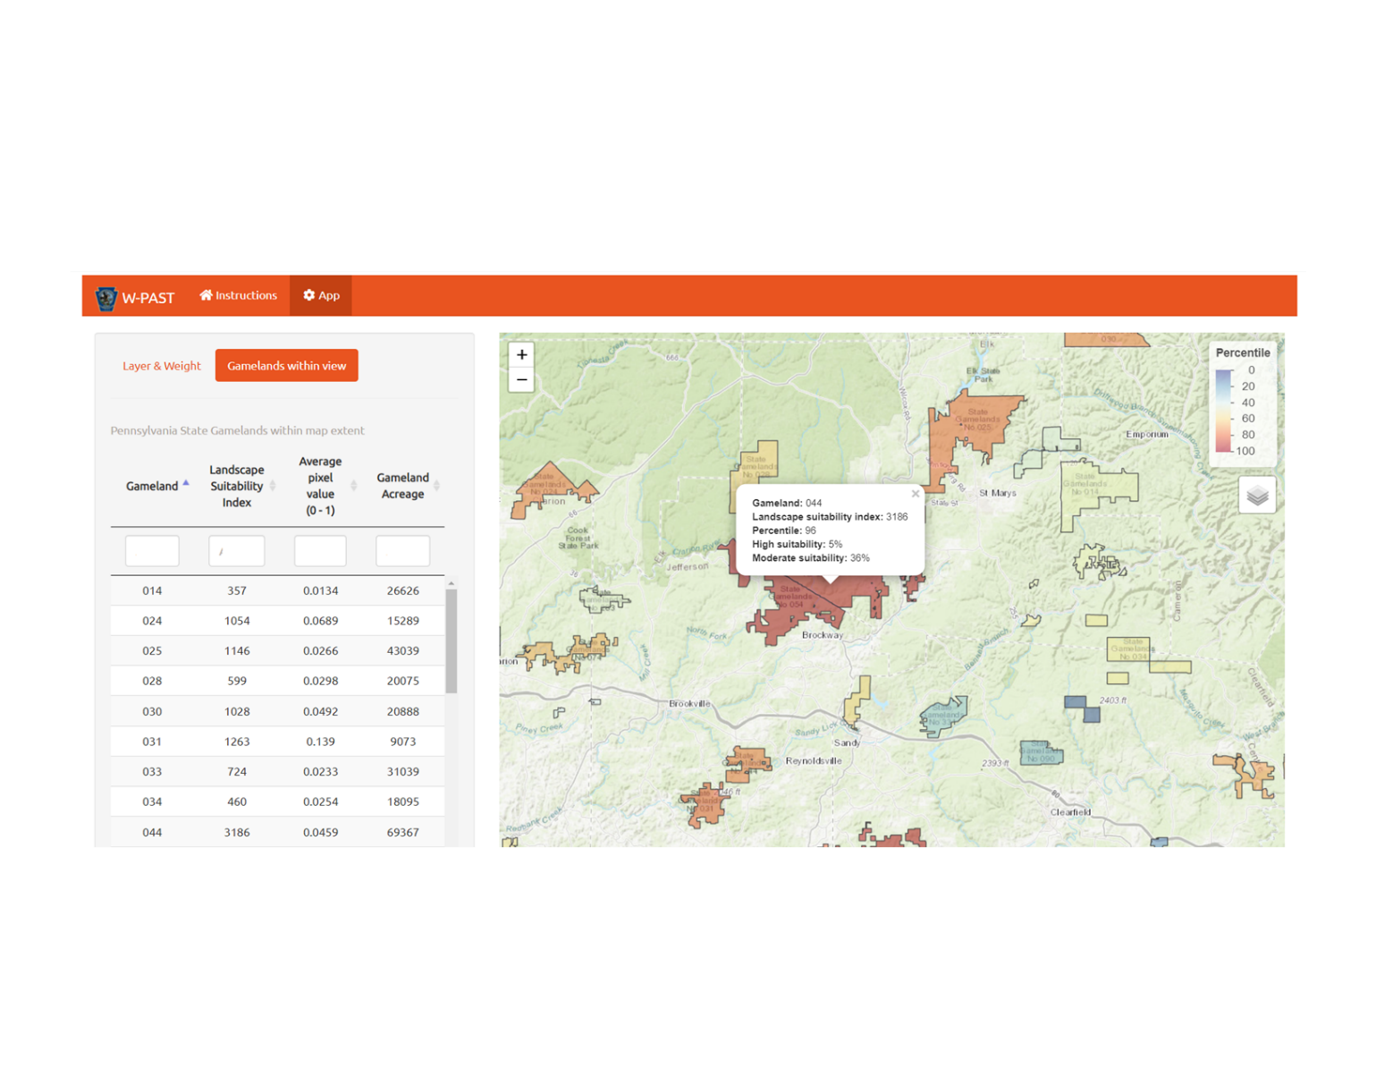

Figure 7. When a gameland is clicked on, its statistics will appear in a pop-up. The types of statistics shown will depend on the layer view which is selected.

### Statistic: Percentile

The percentile statistic shows a state gameland compares to other gamelands for a given statistic (either landscape suitability index or average pixel value, depending on the current layer view). For example, if the Gamelands: landscape suitability index layer was selected, then a gameland with a percentile value of 58 would have a higher landscape suitability index than 57% of all other gamelands. The term percentile is also used to refer to the color ramp in the legend, as all layers are drawn using a percentile scale.

### Statistic: High suitability

The percent of pixels within the gameland that fall within the 67th to 100th percentile of all pixels, or in other words, have a higher value than two thirds of all other pixels in the layer. This can be used to determine what proportion of a gameland has a high potential to host woodcock habitat.

### Statistic: Moderate suitability

The percent of pixels within the gameland that fall within the 64th to 66th percentile of all pixels, or in other words, have a higher value than one third of all other pixels in the layer. This can be used to determine what proportion of a gameland has a moderate potential to host woodcock habitat.

## Changing display options in the map viewer

The stacked layers icon in the map viewer, below the color ramp, allows the user to switch between display options (Fig. 8). The user can toggle between a topographic and satellite map and can choose to display or hide the application results. In the Statewide layer view, this allows the user to hide the predictive layer, and in either of the Gamelands layer views, this allows the user to hide state gamelands.

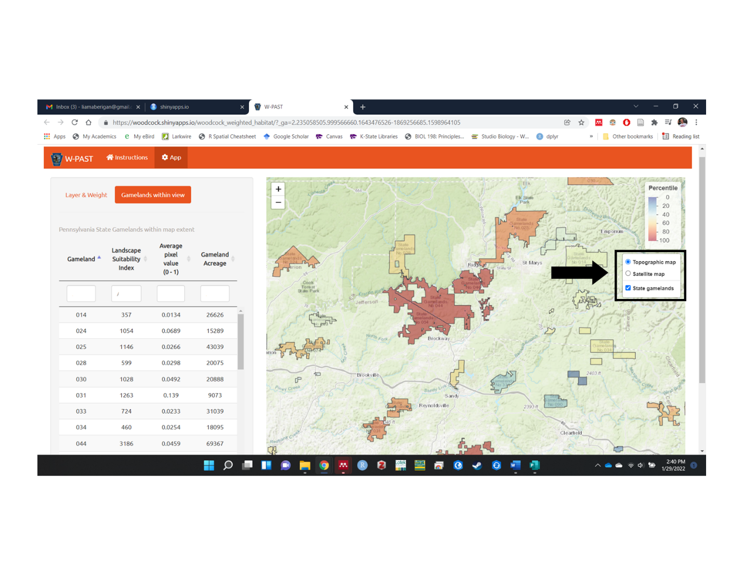

Figure 8. When scrolled over, the stacked layers icon will allow the user to switch between display options.